Selection Sort
Selection Sort repeatedly sorts elements. First find the smallest element in the array and exchange it with the element in the first position, then find the second smallest element and exchange it with the element in the second position, and continue in this way until the entire array is sorted.
The algorithm maintains two subarrays in a given array.
- The subarray which already sorted.
- The remaining subarray was unsorted.

In every iteration of the selection sort, the minimum element (considering ascending order) from the unsorted subarray is picked and moved to the beginning of the unsorted subarray. After every iteration sorted subarray size increase by one and the unsorted subarray size decrease by one.
Generally, on the ith pass through the list, which we number from 0 to n − 2, the algorithm searches for the smallest item among the last n − i elements and swaps it with A_{i}:
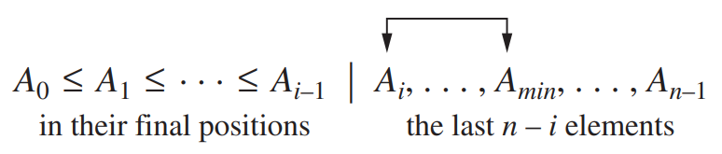

After n − 1 passes, the list is sorted.
ALGORITHM SelectionSort(A[0..n − 1])
//Sorts a given array by selection sort
//Input: An array A[0..n − 1] of orderable elements
//Output: Array A[0..n − 1] sorted in nondecreasing order
for i ← 0 to n − 2 do
min ← i
for j ← i + 1 to n − 1 do
if A[j ]<A[min] min ← j
swap A[i] and A[min]

Example :
Sort the following array using selection sort.
89 45 68 90 29 34 17

| 89 |  | 45 |  | 68 |  | 90 |  | 29 | 34 | 17
17 | | | 45 |  | 68 |  | 90 |  | 29 | 34 | 89
17 |  | 29 | | | 68 |  | 90 |  | 45 | 34 | 89
17 |  | 29 |  | 34 | | | 90 |  | 45 | 68 | 89
17 |  | 29 |  | 34 |  | 45 | | | 90 | 68 | 89
17 |  | 29 |  | 34 |  | 45 |  | 68 | | 90 | 89
17 |  | 29 |  | 34 |  | 45 |  | 68 | 89 | | 90

Example of sorting with selection sort. Each line corresponds to one iteration of the algorithm, i.e., a pass through the list’s tail to the right of the vertical bar; an element in bold indicates the smallest element found. Elements to the left of the vertical bar are in their final positions and are not considered in this and subsequent iterations.

The basic operation here is key comparison,
A[j]<A[min].
The number of times, the basic operation is executed depends only on the array size and is given by,
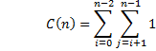
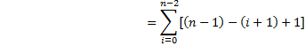
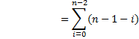

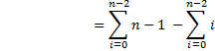

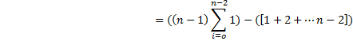
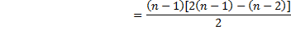
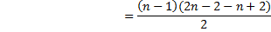
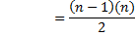
Therefore, C(n)

The number of key swaps is one for every iteration of the loop.ie. Ɵ(n) or (n-1)

